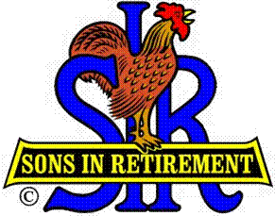

Las Trampas Branch 116

Luncheon Meeting Agenda

January 16, 2017

11:40 AM
- Call to Order – Big Sir.
- Pledge of Allegiance.
- Invocation: Dave Williams
- Introduce Head Table
- Little Sir: Marty Katz
- Chaplin: Dave Williams
- Guest: Bill Holly
- Introduce Guests & Visitors
- Guests:
- Visitors:
- Induct New Members: Jim Dugan (Sponsor: Ron Armijo)
- Big Sir Comments:
- Wayne Smith – Storyteller
- Verify Committee Head Positions for Directory.
- Move to Boundary Oak.
Ballots: Pick one option only. Two marked negates ballot. Ballots will be picked up and counted at the end of the luncheon.
Advantages of the move.

12:00 PM – Lunch

12:15 PM
- Committee Reports
- Sunshine Report – Matt Arena.
- Raffle Drawing

12:30 PM
- Bill Holly – Branch 116 move.
- Jim Barstow presentation with Katie
- Voting – “Do We Go or Do We Stay”???
- Pick up Ballots.

Little Sir:
- Ask December & January Birthday guys to stand / sing Happy Birthday (Paul King & Robbie)
- Drawing for Free Lunch.
- Sign God Bless America.

Count Ballots – Jim Barstow

